Balancing Major and Minor Assignments  Students will be graded in two categories: Major Summative & Minor Summative.  Major Summative  Approximately 1/3 of total points per marking period  Minor Summative  Approximately 2/3 of total points per marking period  Why: Minor work should support the development of content and skills assessed on the major assignment(s). How the student achieves on the minor work should predict their progress on end-of-unit assessments, the major work. Neither minor nor major assignments should make or break a student’s report card grade. | 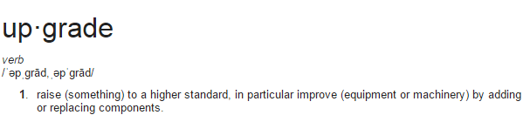  Expectations for Upgrades  Upgrade assignments will be marked with an asterisk (*). The deadline for upgrade eligible assignments will be two weeks after the grade is posted in BCPS One. The deadline can appear in parenthesis after the assignment title or as a comment.  EXAMPLE  Eligible *Multiplying Fractions* (by 12/5)  Not Eligible Multiplying Fractions  No upgrades during the last 10 days of each marking period.  Evidence of new learning must occur before an upgrade opportunity is provided.  Upgrade opportunities will be determined by grade level content teams. Not all assignments will be eligible for an upgrade.  A score of 90% or greater is not eligible for an upgrade.
Major Assignment Examples  Projects  Extended labs  Culminating performances/events  Research reports  Unit tests  Performance Based Assessments  Extended essays | Minor Assignment Examples  Classwork  Homework assigned after instruction  Practice  Discussions  Learning checks/Quizzes  Brief/Extended constructed responses  Exit tickets | Non-Graded: Students will continue to have non-graded assignments. These are used between summative assignments to give students, parents and teachers an indication of how students are progressing towards learning a standard. These assignments should not be considered optional.
Please contact us with any questions or concerns regarding this new grading addendum. 410-887-0112
Deep Creek Magnet Middle
Grading & Reporting Addendum

